Project Report

ON

**SCHOOL DATABASE MANAGEMENT SYSTEM**

**BY**

**Pranay Anantrao Lande**

**(Seat No – 22606)**

**MCA–I (Sem-I)**

**Div-B**

**Under the Guidence of**

**Prof. Asmita Hendre**

**SAVITRIBAI PHULE PUNE UNIVERSITY**

**MASTER OF COMPUTER APPLICATION**



**Dr. D.Y. Patil School of MCA**

**Charoli (BK), PUNE-** **412105**

**Year 2022-2023**

Date:-



**CERTIFICATE**

**This is to certify that Mr. Pranay Anantrao Lande, has successfully completed his/her project work entitled “School Database Management System” in partial fulfillment of MCA -I SEM-I Mini Project for the year 2021-2022. He has worked under our guidance and direction.**

**Place : Pune.**

**Date :**

**Prof. Asmita Hendre Prof. Ashok Deokar Dr. E. B. Khedkar**

**(Project Guide) HOD DYPSOMCA (Director,DYPSOMCA)**

**Examiner 1:……………………………**

**Examiner 2:……………………………**

**Index**

|  |  |  |
| --- | --- | --- |
| **Sr. No.** | **CHAPTER DETAILS** | **Page Number** |
| **1** | **INTRODUCTION** | **1** |
| 1.1 | INTRODUCTION | 1 |
| 1.2 | EXISTING SYSTEM AND NEED FOR A SYSTEM | 2 |
| 1.3 | LIMITATION OF EXISTING SYSTEM | 2 |
| **2** | **PROPOSED SYSTEM** |  |
| 2.1 | PROBLEM STATEMENT | 6 |
| 2.3 | PRODUCT OVERVIEW | 6 |
| 2.4 | OBJECTIVES OF PROPOSED SYSTEM | 6 |
| 2.5 | FUNCTIONAL REQUIREMENTS | 6 |
| 2.6 | NON-FUNCTIONAL REQUIREMENTS | 7 |
| 2.7 | SCOPE OF THE SYSTEM | 3 |
| 2.8 | MODULE SPECIFICATION | 3 |
| 2.9 | OPERATING ENVIRONMENT | 3 |
| **3** | **REQUIREMENT DETERMINATION AND ANALYSIS** |  |
| 3.1 | FACT FINDING METHODS | 4 |
| 3.2 | FEASIBILITY STUDY | 5 |
| **4** | **SYSTEM ANALYSIS AND DESIGN** |  |
| 4.1 | USE CASE DIAGRAM | 9 |
| 4.2 | ACTIVITY DIAGRAM | 11 |
| 4.3 | SEQUENCE DIAGRAM | 12 |
| 4.4 | CLASS DIAGRAM | 10 |
| 4.5 | OBJECT DIAGRAM | 7 |
| 4.6 | ENTITY RELATIONSHIP DIAGRAM | 7 |
| 4.7 | MODULE HIERARCHY DIAGRAM | 13 |
| 4.8 | COMPONENT DIAGRAM | 14 |
| 4.9 | DEPLOYMENT DIAGRAM | 15 |
| 4.10 | WEB SITE MAP DIAGRAM | 16 |
| 4.11 | USER INTERFACE DESIGN SCREEN | 17 |
| 4.12 | TABLE SPECIFICATION | 18 |
| **5** | **DRAWBACKS AND LIMITAION** | **22** |
| **6** | **PROPOSED ENHANSMENT** | **22** |
| **7** | **CONCLUSTION** | **23** |
| **8** | **BIBILOGRAPHY** | **23** |
| **9** | **ANNEXURES** |  |
| **10** | **USER INTERFACE SCREENS** |  |

**1. Introduction:-**

* The main purpose using computerized system is to avoid  manual problems and also documentation storage problem we can’t maintain long period data that’s why we used computerized system to overcome all problem related to school’s data storing and other arias.
* This website handles online student admission procedure.
* Hillfort public school is a web based project that maintains all the activity related to school. This project works on dynamic website handling.
* Hillfort project show time to time event information related to school. It also provides the facility for sending mail to parent regarding student activity.
* The proposed website controls student information and faculty details.
* This is web based project it’s provide privilege facility for security purpose and provide login facility according to designation and restrict unauthorized used, if user is not admin then it can’t access everything, this project provide four type of designation facility and access permission.
* We can generate report according to date & show all report also; Because of manual system we faced many problems. The maintenance cost of manual system was very high. And they didn’t store historical information and not possible to view all at a time.
* This web site reduces the time & cost and provides the facility to retrieve student all information according to requirement.
* School event and all activity related information display on this web site, the school related latest news display on this site
* School related all information display on this project.

**1.2 Abstract**

school Management System is an online service that can be setup for your school to help manage student, teacher, keep track with detailed statistics, school management.

* Its simple, it's effective.
* Here is our feature list which is continually growing:
* Manage all the data of school
* Complete site statistics (graphs).

**1.3 Limitation of Existing System:**

In the present School Management System, it is uneasy to store the information related to students, faculty and parents on the paper. As there is too many information when someone tries to access any of stored information it becomes a difficult and time-consuming task.

The drawbacks in Student**Management System** software can be**counted on fingers; with mostly only benefits,** these systems**have a few countable downsides.** Often, applications face minor technical glitches and these systems are no exception but, ratification is immediate.Only, people who are accustomed to regular use of smartphones or computers can operate.

**Need For System**

* Student Information. Attendance, homework, discipline, grades and achievements! Every information that is related to students can be easily accessed using a school management system.
* Parent Access. Parents play a crucial part in the child’s education. They are continuously involved in it. ...
* Teacher Information. A school management system not only gives information about students. It can provide real-time information about teachers activities also.
* SMS and Real-time app notifications. The communication between teachers and parents is an essential factor in a student’s academic success.
* Attendance Management. An attendance management system is an essential feature of school ERP software

**1.4 Scope of the system :**

Today people are highly lean towards digitalization. Since there is the fierce competition in education industry, every institute must adopt the digital system for staying ahead. School management system helps the schools to run the smooth functions as well as keep right data handy.

With school management software, you may offer the effective educational services. In addition to, it’s the most convenient tool for improving your services. For example, your institute has just started some new courses; you will be able to send direct notification to all the students.

Need for computerized database is coming up where parents want to get connected with their children school report. Thus, right school management is necessity right now. Demand for the school management system will increase in the near future.

Since it offers high collaboration opportunities and you can promote as well as extend your educational solutions. This system allows you save time as well as resources to just focus on the quality education. In the digital era today, it is the right time to offer not just the systematic admission process but trouble-free admission experience to students. You can get School management software & efficiently handle your admission procedure all along with managing essential school operations.

**1.5 Operating Environment-Hardware and Software**

* **Hardware Requirement**
* Processor : Intel Pentium IV or more
* Ram : 512 MB or more
* Cache : 1 MB
* Hard Disk : 10 GB recommended

**Software Requirement:-**

* Client on Internet: Web Browser, Operating System (any)
* Web Server: Operating System (any), Apache 2
* Database: MySQL
* Scripting Language: JAVA, PHPScript, JQuery

**2. Proposed System:-**

* The aim of proposed system is to develop a system of improved facilities. The proposed system can overcome all the limitations of the existing system. The system provides proper security and reduces the manual work.

* Security of data.

* Ensure data accuracy's.

* Proper control of the higher officials.

* Minimize manual data entry.

* Minimum time needed for the various processing.

* Greater efficiency.

* Better service.

* User friendliness and interactive.

* Minimum time required.

**2.1 Feasibility Study:-**

A procedure that identifies, describes, and evaluates candidate systems and selects the best system for the job is called as Feasibility study.

Three key considerations are involved in the feasibility analysis:

1. Technical Feasibility
2. Economic Feasibility
3. Operational Feasibility

**Technical Feasibility:-**

The use of CSS and .NET makes form design easy and convenient. The project can be run on any system with minimum requirements. It reduces data entry errors because of data entry validation, it can be easily handled by any user, and it also helps in faster data up dations. Also the project though developed in GUI, it is very easy to operate. Hence the project is technically feasible.

**Economic Feasibility:-**

Cost benefit analysis is very important in deciding whether the project is economically feasible or not. Itis alone sufficient to save our time and money. It is one time investment and does not require regular maintenance. Through cost benefit analysis it was concluded that the benefits outweigh costs and thus the project is economically feasible.

**Behavioural Feasibility:-**

Behavioural feasibility determines how much effort will go into educating, selling and training the user staff on a candidate system. The project was also evaluated to be behaviourally feasible as it is very user-friendly and hardly needs any extra efforts to educate user for its utility and functioning.

**Present System in use:-**

The present system consists of static web pages and do not allow dynamic insertions of data. Hence there is a need to create a dynamic website.

* System can be web-based so that everyone can easily interact with system.
* System can provide optimize functionality.
* System can be customizable so that one can update it.
* System can be flexible enough so that it can incorporate different changes time to time.
* All the information related with HILLFORT PUBLIC SCHOOL can be documented.
* The most important thing is security. All the data should remain consistent and secure.

**2.2 Objectives of Proposed System :**

Hill fort public School is web based project that is maintain all the activity related to School, it store all the information of student, Hill Fort Project provide sending mail to parent regarding student activity detail.

Hill fort project show time to time event information related to school, hill fort project provide the facility for suggestion regarding school rules and regulation and student complaint.

* To provide student detailed information and faculty details.
* To make admission procedure fast and easy.
* To inform student with time to time event information and notices.
* To inform parents about student activities through email.
* To generate separate student and faculty login Id and password.

**3. Analysis and design**

**3.1 Software Requirement**: -

School administrator wants to build the system that technically and economically strong and helpful to company progress. He wants to reduce large man-power involved   in company to perform the task that high company cost and slow company work. For future use all documents are kept in written or in a file in secure manner. If a file gets lost it cannot be retrieved in any way. A large storing area is required to store the data manually.

The purpose of software requirements specifications is to provide a framework that enables the manager to take reasonable estimates of resources, cost and schedule. These estimates are made with a limited time frame at the beginning of a software project and should be updated regularly as the project progresses. In addition estimates should attempt to define best case and worst case scenarios so that project outcomes can be bounded.

To gather the requirement of client’s need, we take the idea about the data flow from other school websites and also refer documents of school.

**Functional Requirements**:-

• The system runs of apache server so it is needed that server must have apache server version 2.0 available

• Functional requirements are mandatory which means it is compulsory and needed to be fulfilled. They generally describe and define features of end product of software system and simply focuses on what the end product does.

These are the requirements that a system should accomplish or do like calculations, data manipulations, etc. It is very easy to find out functional requirements and captured in use cases.

A system should provide a statement of service which describes how system reacts to inputs provided and should be clear and how a system reacts in a particular situation. Functional requirements are type of requirements that depends upon type of software as different software has a different functional requirement, system on which software is used as it heavily affects functions of software and users to fulfill their requirements. Functional requirement of users is high-level abstract statements. it generally describes of what system should whenever required but system functions should be described in detail by functional system requirements.

**Non-Functional Requirements :-**

Non-functional requirements are not mandatory which means that they are not compulsory to be fulfilled. The non-functional requirements define system properties and system performance. Different properties of a system are there which can be Reliability, response time, maintainability, availability, storage requirements.

It simply focuses on how the end product works and it is not very easy and hard to find out non-functional requirements and captured as a quality attribute. Testing includes performance, stress, security testing, etc. Non-functional requirements are more disapproved and if the non-functional requirements are not fulfilled then complete system is of no use.

**Example –**  
Product requirement, organizational requirement, external requirement, capacity or storage requirement, resources requirement, overall performance requirement time, etc.

**3.2 Entity Relationship Diagram(ERD) :**

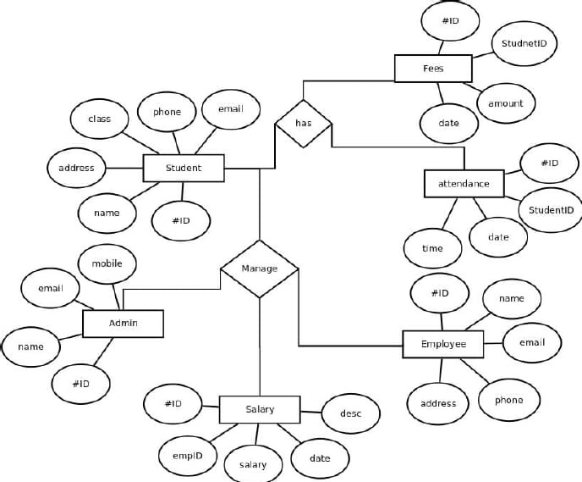

**3.3 Data Dictionary**

**Table 1:Login**

|  |  |  |  |
| --- | --- | --- | --- |
| **Sr.no** | **Field Name** | **Constraint** | **Description** |
| 1 | UserName | NotNull | Enter Username |
| 2 | Password | NotNull | Enter Valid Password |

**Table 2:Add New Members**

|  |  |  |  |
| --- | --- | --- | --- |
| **Sr.no** | **Field Name** | **Constraint** | **Description** |
| 1 | ID | NotNull | Id of member |
| 2 | First Name | NotNull | First Name of member |
| 3 | Last Name | NotNull | Last Name of member |
| 4 | Positon | NotNull | Member Position in School |
| 5 | Birth day | NotNull | Birth Date of Member |
| 6 | Mobile No. | NotNull | Member contact number |
| 7 | Sex | NotNull | Gender of Member |
| 8 | Permanent Address | NotNull | Member Permanent Address |
| 9 | Present Address | NotNull | Member Present Address |

**Table 3:Update Details**

|  |  |  |  |
| --- | --- | --- | --- |
| **Sr.no** | **Field Name** | **Constraint** | **Description** |
| 1 | ID | NotNull | Id of member |
| 2 | First Name | NotNull | First Name of member |
| 3 | Last Name | NotNull | Last Name of member |
| 4 | Positon | NotNull | Member Position in School |
| 5 | Birth day | NotNull | Birth Date of Member |
| 6 | Mobile No. | NotNull | Member contact number |
| 7 | Sex | NotNull | Gender of Member |
| 8 | Permanent Address | NotNull | Member Permanent Address |
| 9 | Present Address | NotNull | Member Present Address |

**3.4 Use Case Diagram :**

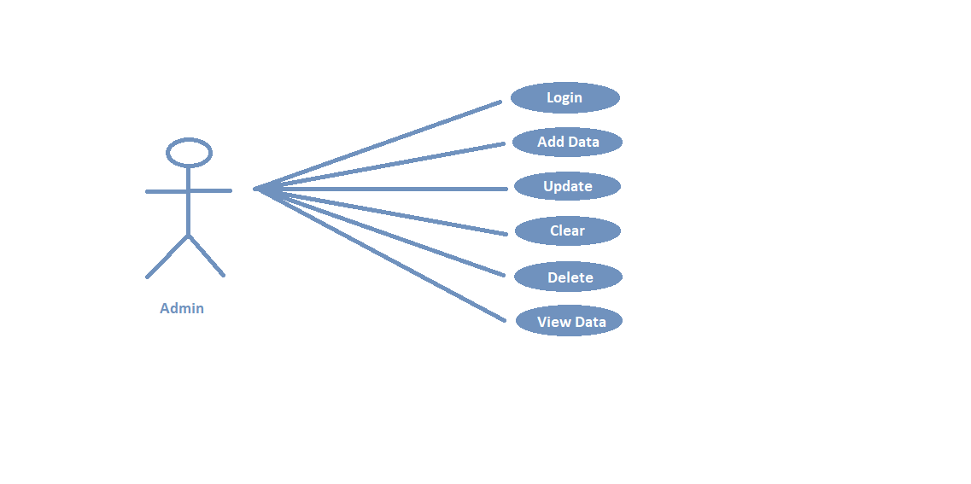

**3.5 Class Diagram**

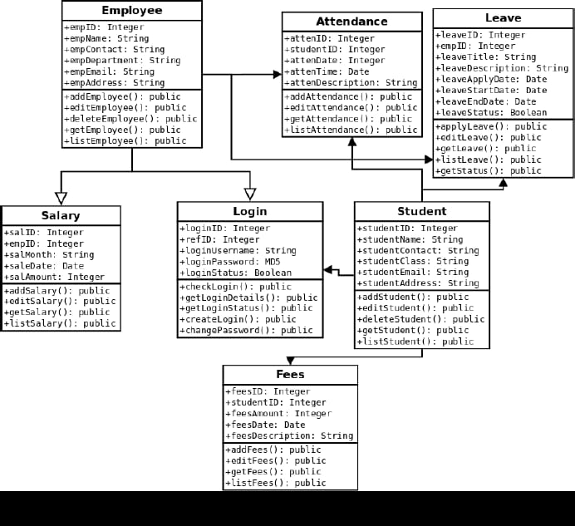

**3.6 Activity Diagram**

Access the internal functionalities according to permissions

Admin is Registered

Set userlevel & permission

Login to the system

successfully

Check Login ID password

Admin Login ID&Password

**3.7 Sequence Diagram :**

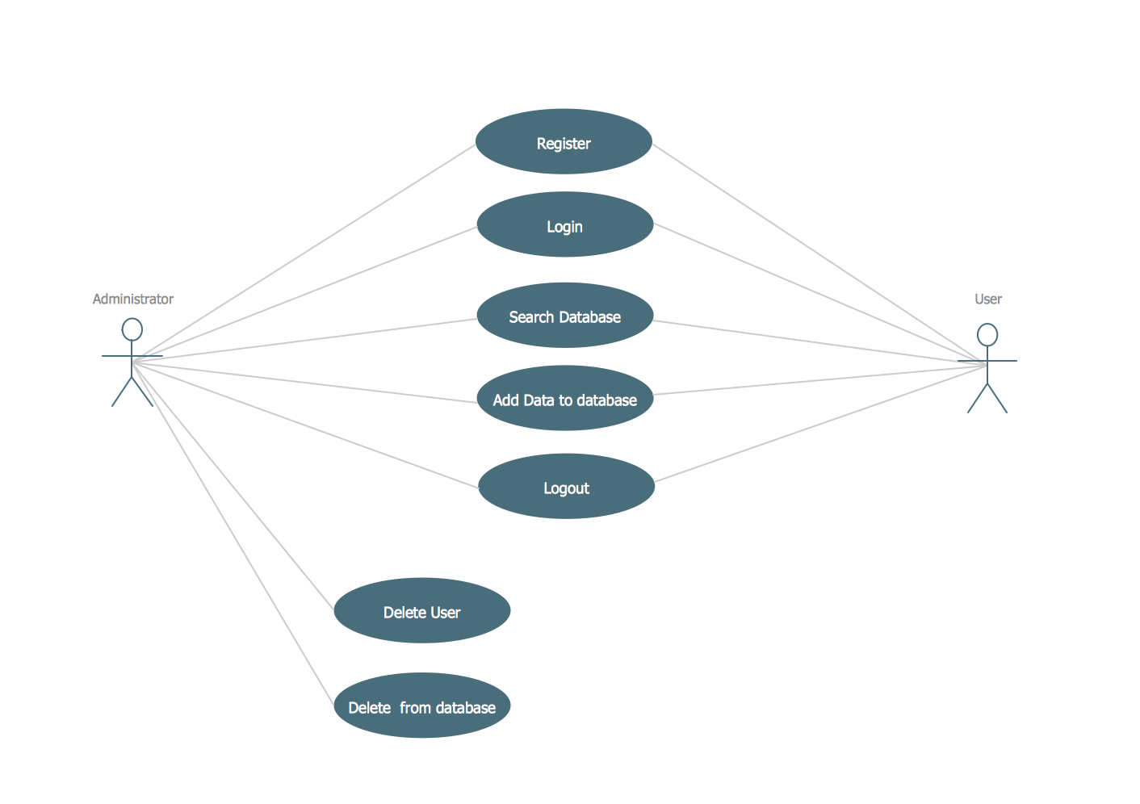

**3.8 Input And Output Screen**

**Database Tables :**

* A table is a set of data elements (values) that is organized using a model of vertical columns (which are identified by their name) and horizontal rows. A table has a specified number of columns, but can have any number of rows.
* List of Tables in Database:
* Name of Database is “school”

**Login Page:**

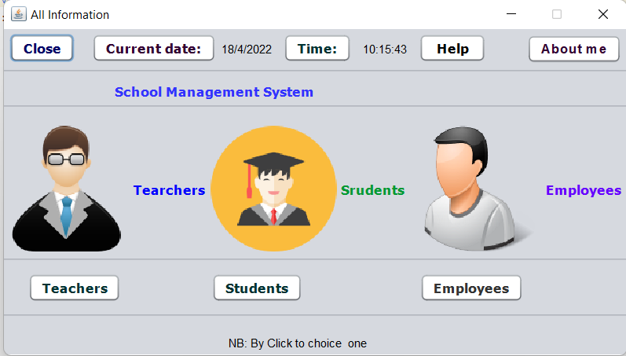

**Teacher’s Information System :**

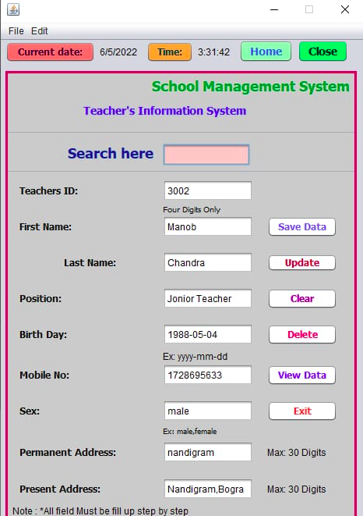

**Student’s Information System:**

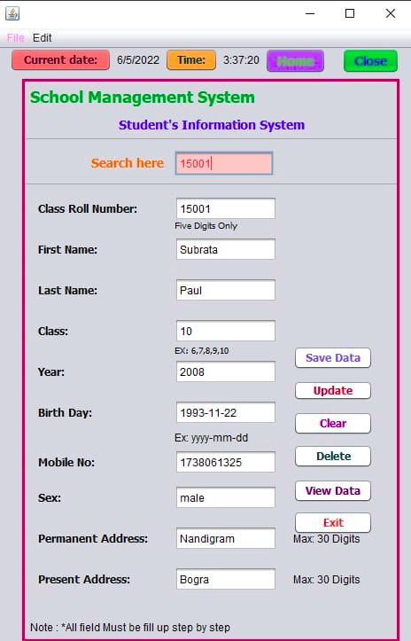

**Employee’s Information System :**

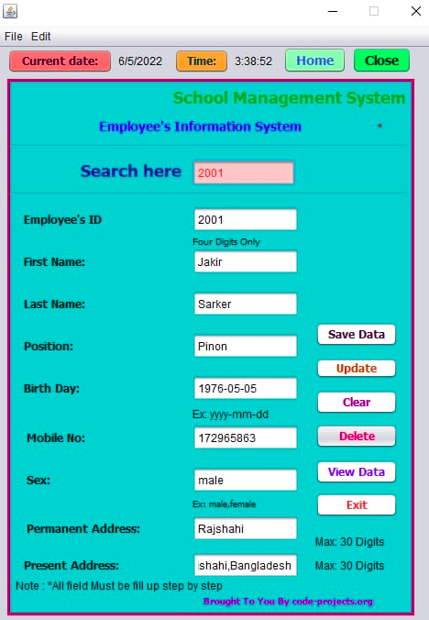

**Teachers Database :**

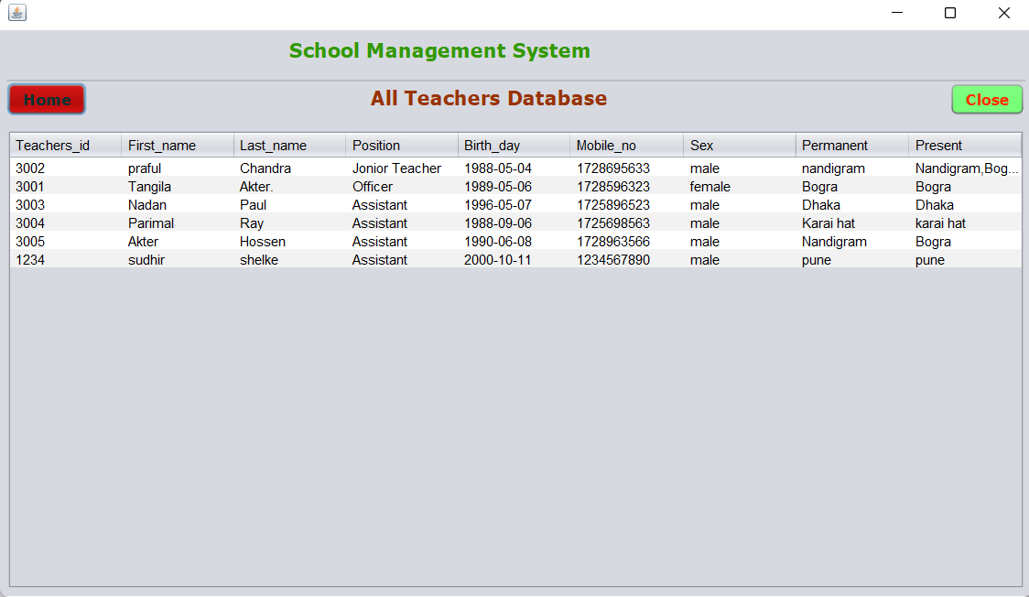

**Employees Database :**

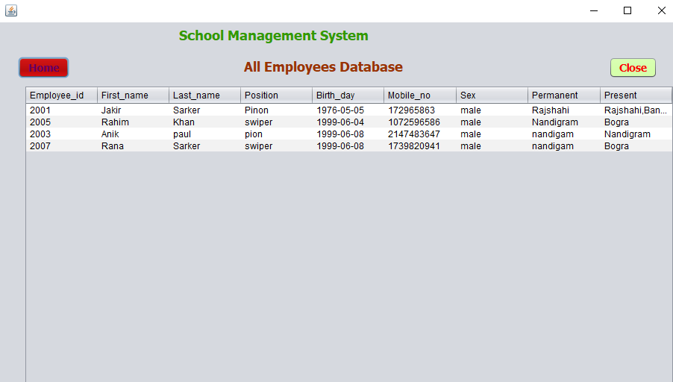

**Students Database :**

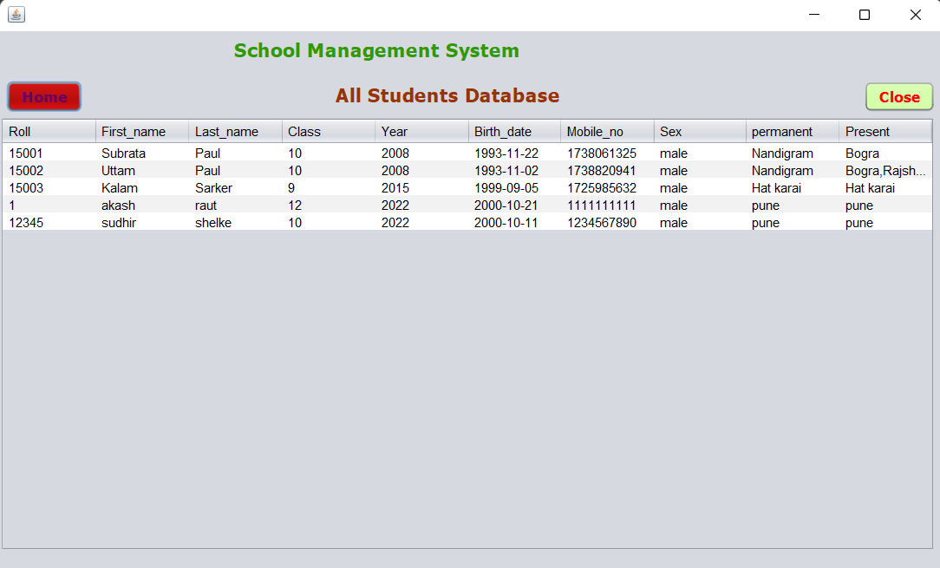

**Coding:-**

import java.awt.event.WindowEvent;

import java.sql.*;

import javax.swing.*;

import java.awt.*;

import java.awt.event.*;

public class Admin extends javax.swing.JFrame {

Connection conn=null;

ResultSet rs=null;

PreparedStatement pst=null;

public Admin() {

initComponents();

conn=javaconnect.connerDb();

}

public void close()

{

WindowEvent winClosingEvent = new WindowEvent(this, WindowEvent.WINDOW_CLOSING);

Toolkit.getDefaultToolkit().getSystemEventQueue().postEvent(winClosingEvent)

}

@SuppressWarnings("unchecked")

// <editor-fold defaultstate="collapsed" desc="Generated Code">//GEN-BEGIN:initComponents

private void initComponents() {

jLabel1 = new javax.swing.JLabel();

jLabel2 = new javax.swing.JLabel();

jLabel3 = new javax.swing.JLabel();

txt_pass = new javax.swing.JPasswordField();

cmd_admin = new javax.swing.JButton();

setDefaultCloseOperation(javax.swing.WindowConstants.EXIT_ON_CLOSE);

jLabel1.setText("If are a Admin,you can Delete Only.");

jLabel2.setText("Please Enter Admin Password");

jLabel3.setText("Password:");

cmd_admin.setText("Go");

cmd_admin.addActionListener(new java.awt.event.ActionListener() {

public void actionPerformed(java.awt.event.ActionEvent evt) {

cmd_adminActionPerformed(evt);

}

});

javax.swing.GroupLayout layout = new javax.swing.GroupLayout(getContentPane());

getContentPane().setLayout(layout);

layout.setHorizontalGroup(

layout.createParallelGroup(javax.swing.GroupLayout.Alignment.LEADING)

.addGroup(layout.createSequentialGroup()

.addGroup(layout.createParallelGroup(javax.swing.GroupLayout.Alignment.LEADING)

.addGroup(layout.createSequentialGroup()

.addGap(105, 105, 105)

.addComponent(jLabel1))

.addGroup(layout.createSequentialGroup()

.addGap(58, 58, 58)

.addGroup(layout.createParallelGroup(javax.swing.GroupLayout.Alignment.TRAILING)

.addComponent(jLabel2)

.addGroup(layout.createSequentialGroup()

.addComponent(jLabel3)

.addGap(18, 18, 18)

.addComponent(txt_pass, javax.swing.GroupLayout.PREFERRED_SIZE, 137, javax.swing.GroupLayout.PREFERRED_SIZE))

.addComponent(cmd_admin))))

.addContainerGap(92, Short.MAX_VALUE))

);

layout.setVerticalGroup(

layout.createParallelGroup(javax.swing.GroupLayout.Alignment.LEADING)

.addGroup(layout.createSequentialGroup()

.addContainerGap()

.addComponent(jLabel1)

.addGap(18, 18, 18)

.addComponent(jLabel2)

.addGap(34, 34, 34)

.addGroup(layout.createParallelGroup(javax.swing.GroupLayout.Alignment.BASELINE)

.addComponent(jLabel3)

.addComponent(txt_pass, javax.swing.GroupLayout.PREFERRED_SIZE, javax.swing.GroupLayout.DEFAULT_SIZE, javax.swing.GroupLayout.PREFERRED_SIZE))

.addGap(18, 18, 18)

.addComponent(cmd_admin)

.addContainerGap(51, Short.MAX_VALUE))

);

pack();

}// </editor-fold>

private void cmd_adminActionPerformed(java.awt.event.ActionEvent evt) {//GEN-FIRST:event_cmd_adminActionPerformed

String sql="select * from Admin where Password=?";

try {

pst=conn.prepareStatement(sql);

pst.setString(2, txt_pass.getText());

rs=pst.executeQuery();

if(rs.next()){

JOptionPane.showMessageDialog(null, "Log in Successful.");

rs.close();

pst.close();

close();

}

else{

JOptionPane.showMessageDialog(null, "You Enter Worng Password.");

}

} catch (Exception e) {

JOptionPane.showMessageDialog(null, e);

}

}//GEN-LAST:event_cmd_adminActionPerformed

try {

for (javax.swing.UIManager.LookAndFeelInfo info : javax.swing.UIManager.getInstalledLookAndFeels()) {

if ("Nimbus".equals(info.getName())) {

javax.swing.UIManager.setLookAndFeel(info.getClassName());

break;

}

}

} catch (ClassNotFoundException ex) {

java.util.logging.Logger.getLogger(Admin.class.getName()).log(java.util.logging.Level.SEVERE, null, ex);

} catch (InstantiationException ex) {

java.util.logging.Logger.getLogger(Admin.class.getName()).log(java.util.logging.Level.SEVERE, null, ex);

} catch (IllegalAccessException ex) {

java.util.logging.Logger.getLogger(Admin.class.getName()).log(java.util.logging.Level.SEVERE, null, ex);

} catch (javax.swing.UnsupportedLookAndFeelException ex) {

java.util.logging.Logger.getLogger(Admin.class.getName()).log(java.util.logging.Level.SEVERE, null, ex);

}

//</editor-fold>

java.awt.EventQueue.invokeLater(new Runnable() {

public void run() {

new Admin().setVisible(true);

}

});

}

// Variables declaration - do not modify//GEN-BEGIN:variables

private javax.swing.JButton cmd_admin;

private javax.swing.JLabel jLabel1;

private javax.swing.JLabel jLabel2;

private javax.swing.JLabel jLabel3;

private javax.swing.JPasswordField txt_pass;

// End of variables declaration//GEN-END:variables

}

1. **Limitations of proposed System:**

A School Database management system is a software/tool that helps manage everything related to school easily.

* 1. **Better Management of school Data**
  2. A complex user interface.

## Database handling staff required

* 1. Database Security

**5. Future Enhancements :**

1. **Academy Management -** Manage Session , Terms, Subjects, Classes.
2. **Student Management -**  Add Student , Bulk Add Student,  Fees Details Check , View Profile.
3. **Employee Management -** Add Employee, Edit Employee, View Employee.
4. **Fees Management -**  Add Fees , Delete Fees, Pay fee , Fees Structure , customize fee Structure.
5. **Result Management -**  Add Result , Edit Result , Manage Result.

**6. Conclusion**

Schools have piles of documents containing records of students and personnel. There are lots of management areas that need to be processed for the operation of the school. The study was conducted to assess the current management system used in schools. The researchers gather information for the initial investigation, and the result reveals that schools face difficulties recording and storing different data. Thus, the researchers developed an automated school management system in Java and presented it to the intended end-users and respondents.

The findings of the research showed that the produced system matched the demands and requirements of the respondents as well as those of the target users. The respondents rated the system satisfactorily in user acceptability, functionality, efficiency, productivity, quality, portability, and timeliness. The system will make school management easy, fast, convenient, and efficient.

1. **Bibliography :**

* [www.wikipedia.org](http://www.wikipedia.org/)
* [www.codeproject.com](http://www.codeproject.com/)
* Ken Arnold and James Gosling, *The Java Programming Language*, Addison-Wesley, 1996, ISBN 0-201-63455-4.
* Doug Lea, *Concurrent Programming in Java*, Addison-Wesley, 1997, ISBN 0-201-69581-2.